Social Capital, human capital and flight paths to opportunity and employment for Visually Impaired
3rd International Optometry and Vision Science Conference, Edinburgh 8-9th October 2018
Dr John A Patterson, Principal St. Vincent’s School for Sensory Impairment, Liverpool UK

Abstract
Statement of the Problem: High unemployment amongst visually impaired (VI) young people remains a global concern; as does the connected impact on health and wellbeing attached to the lack of opportunity and meaningful engagement. This study documents how linking schools, universities, and businesses to mobilize resources and support for career choice for VI students ( Patterson and Loomis 2016) in Liverpool, England has developed and is progressing with measurable outcomes attached to friendship group generation and employment opportunities on a local, national and international platform. Driven through participation in sport and the raising of self esteem, we connect Science Technology Engineering and Maths (STEM) and research development and innovation surrounding the making and sharing of VI access technologies with the international VI community through the physical SIGHTBOX medium ( www.sightbox.org.uk) Connecting with community , VI engagement in sport and making reference to the United Nations Sustainable Development Goals (SDG’S) throughout, we present our outcomes focussed formula for the research community consideration in seeking to connect more closely medicine with education through teaching and learning i.e. Social/ Human Capital + Reverse inclusion + Service learning + creativity = Outcomes

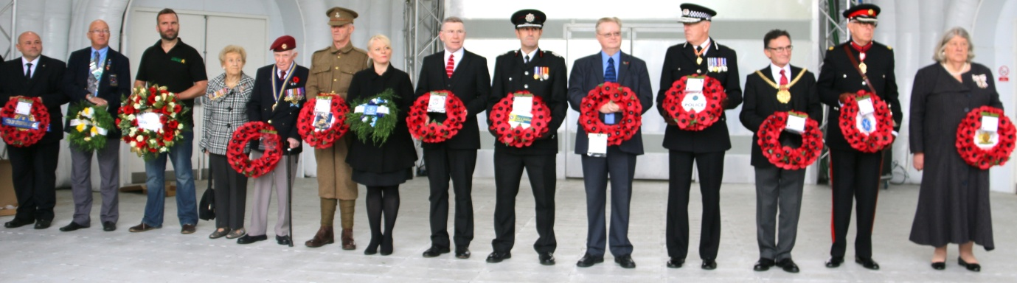

Recent Publications
- Hewett, R., & Keil, S. (2015) Investigation of data relating to blind and partially sighted people in the Quarterly Labour Force Survey: October 2011-September 2014. University of Birmingham with Royal National Institute of Blind People, England.
- Patterson, J., Loomis, C (2015) Teacher Education for Equity and Sustainability Network (TEESNet) Eighth Annual Conference9th July 2015, Liverpool Hope University From Curriculum Makers to World Shapers: Building Capacities of Educators for a Just and Sustainable World. Post conference paper 'Education and Enterprise' Village: supporting visually impaired (VI) learners locally, nationally and internationally through ‘values’ education and service-learning
- Patterson, J. (2011) ‘Developing the Role of ‘Values’ Within Information and Communication Technology: An Introduction to the Schools Intergenerational Nurturing and Learning Project’. In: Bowdon, M. and Carpenter, G. (Eds.) Higher Education, Emerging Technologies, and Community Partnerships: Concepts, Models, and Practices. IGI Global (p.329-338).

- Patterson, J., Loomis, C (2016) Manuscript ID BJVI-15-0044 British Journal of Visual Impairment "Linking schools, universities and businesses to mobilize resources and support for career choice and development of students who are visually impaired”
- Patterson, J., Loomis, C (2018) Teacher Education for Equity and Sustainability Network (TEESNet) Tenth Annual Conference 10th Annual Conference, Liverpool Hope University September 2017 Making the Sustainable Development Goals Real: The Role of Teacher Education in Promoting Quality Education for Sustainable Development and Global Citizenship Education in Schools. LITTLE STORIES and BIG PICTURES: Quality education addresses social and economic inequality for the visually impaired locally and globally

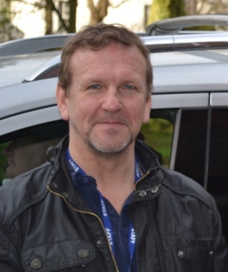
Biography
Originally an engineer, John retrained as a primary teacher serving in Liverpool inner city schools and across public private and voluntary sectors within EU Objective One programmes as community and education consultant leading to a Senior Lecturer role as Head of Physical Education on teacher education programmes at Liverpool Hope University. His MSC and PhD surround social capital, social enterprise, volunteerism and curriculum design. He is currently Principal at St. Vincent’s, a residential non-maintained School for VI in West Derby Liverpool rated as OUTSTANDING by The Office for Standards in Education. His research and focus remains with securing outcomes for VI young people

